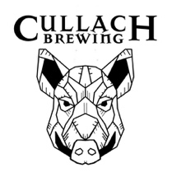

PIZZA MENU

MARGHERITA (V)

Sourdough Base, Napoli Sauce, Scottish mozzarella & Basil Leaf Garnish – vegan option available!

£10.50

ANTI-PASTI (V)

Sourdough Base, Napoli Sauce, Scottish Mozzarella, Sundried Tomatoes, Black Olives, Artichoke Hearts & Rocket Leave Garnish – Vegan option available!

£11.50

BREAKFAST PIZZA

Sourdough Base, Napoli sauce, Scottish Mozzarella, Black pudding, smoked streaky bacon, Portobello mushrooms, Scottish chipolata sausage & a tomato ketchup drizzle

£13.50

HIGHLAND HEATER

Sourdough Base, Napoli Sauce, Scottish Mozzarella, Venison Salami, Chorizo, Piquante chilli peppers & basil leave garnish – vegan option available!

£11.50

HALLOUMI & PARMA HAM

Sourdough Base, Napoli sauce, Scottish Mozzarella, Halloumi, Red Pepper, Parma Ham Prosciutto strips, sundried tomato, Rocket, pesto & Parmesan Dusting – Vegan option available!

£12.50

VEGAN SPICY CHICKEN (VE)

Sourdough base, Napoli sauce, Vegan Mozzarella, Seitan strips, jalapeno chilli peppers

£11.50

- Gluten Free & Kids options also available. Please ask staff for allergen information. -

